**Learning Hunting behavior in cubs through Observation, Imitation and Reinforcement Learning**

Pragadheeshwaran Thirumurthi Prarthana G Alevoor

Department of Computer Science

{pragadh, prar1986}@cs.ucla.edu

Professor: Michael Dyer {dyer@cs.ucla.edu}

**Hypotheses:**

* Implementing learning of hunting behavior in a Cub
* At a later stage the cub transmits the learnt behavior to its children
* The process is carried out in three phases:

1. Observation Phase
2. Imitation / Reinforcement Learning Phase
3. Self-Learning Phase
4. **Phase 1:**
   1. The cub observes the hunting behavior of the mother.
   2. The cub learns various goals that have to be applied under different environment (type and nature of prey).
5. **Phase 2:**
6. The cub imitates the actions learnt from mother
7. The mother gives reinforcement for the actions that the cub performs.
8. The cub uses positive reinforcement learning from the mother to achieve the goal.
9. **Phase 3:**
10. The cub performs actions on its own
11. The cub senses new environment and implements its learnt behavior
12. It uses negative reinforcement learning by itself
13. A special neuron gets activated when the Cub becomes mother

**Goals:**

1. The cub learns how to hunt a prey by **observing** the mother.
2. The cub senses the environment and applies appropriate type of hunting behavior.
3. The cub does the hunting by **imitating** the mother
4. The mother gives feedback as a form of reinforcement to the cub.
5. The cub continues the same actions in case of positive reinforcement.
6. The cub performs different actions in case of negative reinforcement.
7. Predator should sense the presence of a group and take necessary actions for group hunting

**Environment:**

The animats world consists of Preys and Predators.

1. **Prey:**
2. Goat:
3. Small sized goat
4. Medium sized goat
5. Large sized goat
6. Large sized buffalo
7. **Predator:**
   1. Lion Mother
   2. Cub

* Images are used to represent animats.
* Different sized images to represent sizes of animats.

C:\Users\Prag\workspace\ImitationLearning_PRAR_IL_R_03_18_2012_23.00\ImitationLearning\src\Animats\goat3.gifC:\Users\Prag\workspace\ImitationLearning_PRAR_IL_R_03_18_2012_23.00\ImitationLearning\src\Animats\goat1.gifC:\Users\Prag\workspace\ImitationLearning_PRAR_IL_R_03_18_2012_23.00\ImitationLearning\src\Animats\goat2.gifC:\Users\Prag\workspace\ImitationLearning_PRAR_IL_R_03_18_2012_23.00\ImitationLearning\src\Animats\buff.jpgC:\Users\Prag\workspace\ImitationLearning_PRAR_IL_R_03_18_2012_23.00\ImitationLearning\src\Animats\lion.gifC:\Users\Prag\workspace\ImitationLearning_PRAR_IL_R_03_18_2012_23.00\ImitationLearning\src\Animats\cub.jpg

**Physics:**

1. Environment
   1. The environment is depicted in a 500 x 500 board
   2. Animats, when created, are placed at random co-ordinates in the board
2. Prey
3. Preys are dumb.
4. If Predator in range,
   1. Prey moves in a direction away from predator.
5. Else
   1. Prey moves in random direction
6. Prey can increase speed if it senses a predator in its range.
7. Predator
8. Predators are smart.
9. If Prey is in range,
   1. Predator finds direction of prey and moves in that direction.
10. Else
    1. Predator moves in random direction if no prey is in range
11. Predator attacks the prey by overcoming the speed and energy of the prey
12. Vision Sensor:
    1. Cub’s have a shorter vision range than mother lion.
    2. Cub’s vision range improves over age.
13. Motion/Action:
    1. Each animat moves by a constant step
    2. Prey can perform the following actions:
       1. Search/Scan for other animats
       2. Walk
       3. Run
       4. Claw
       5. Pounce
       6. Snarl
14. Energy:
    1. Amount of energy consumed depends on the type of the action performed
    2. Predator Hunts based on energy (hunt when the energy is between 20% – 80%)
    3. The predator drawbacks from hunting if it energy becomes too low.
    4. Each of the above actions consume energy
    5. The Predator gains energy on hunting/eating a prey
15. Animats
    1. Movement of the animat is controlled changing the x,y co-ordinates of the animat
    2. Animats have vision sensor.
    3. Animats can see in 360 degree
    4. Each animat has a sense range.
    5. Animats have motion motor
    6. Animats can move in any of the Eight directions.
    7. Each animat has an energy level.
    8. Energy of an animat ranges from 0-100.
    9. Animat dies when the energy level drops to 0.

Each animat has:

1. Vision Range
2. Animat type
3. Size
4. Energy
5. x,y co-ordinate
6. width
7. height
8. animat image

**Implementation:**

Each of the objects are kept in a collection depending on its type.

In order to facilitate the cub's learning process, several preys are introduced.

Collsion avoidance is take care.

Prey can run into other preys

Predator can run into other predators

As images consume an area of co-ordinates, images might go over each other.

If a Predator comes with the image area of the prey, the pery is killed and removed from the board.k

**Instrumentation:**

Data collected on each experimental run:

1. Sense environment to observe the location of prey
2. Actions performed by the mother
3. Actions cub performed in the previous step
4. Mother identifies the action cub should have performed

**Methodology:**

**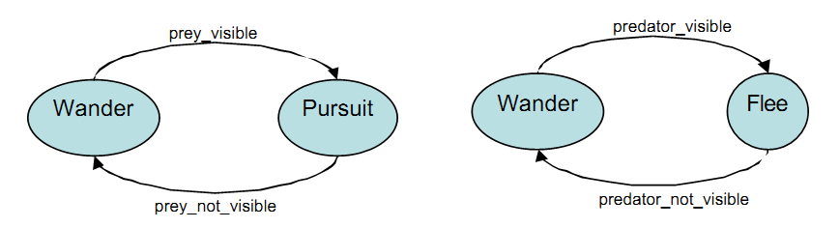**

**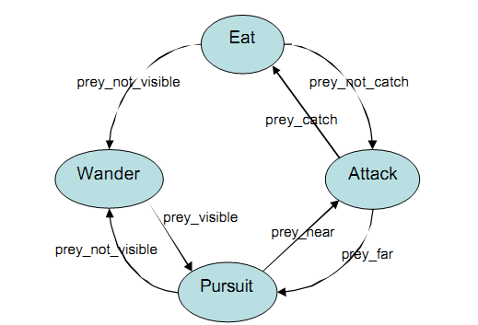**

**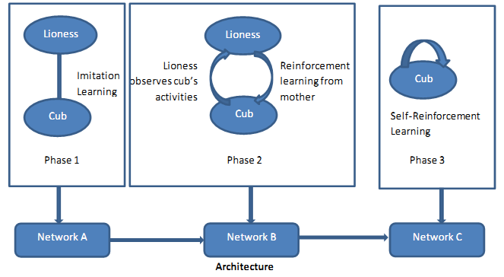**

**Phase 1:**

The cub’s neural network does not know the goals (what to hunt, when to hunt) and how to achieve them.

By observing the mother, the cub builds its neural network and learns the goals and the sequence s of actions for various goals.

Goals include the sequence of actions that a cub should perform for a hunt.

Initial hunting behavior includes both successful and unsuccessful hunt.

One-to-one connection between sensors that detects the properties of the lioness and corresponding sensor and effector nodes in the cub

Scenario: When the lioness senses a small prey, it first snarls and then pounces.

This triggers the snarl and pounce motor neuron in the cub.

**Phase 2:**

In this phase,the cub stops following the mother.

The cub processes environmental information and chooses appropriate action that has to be applied.

Various actions include

1. Pounce
2. Snarl
3. Claw
4. Run
5. Search

The sensors and effector nodes of the cub gets triggered when an action is initiated by the cub

Scenario: The cub sees the prey its snarl and pounce motor neuron gets triggered.

The weights in the network are altered by the reinforcements from the mother.

**Phase 3:**

The cub is detached from lioness

The cub no more receives reinforcement from the mother

In case of an unsuccessful hunt, the cub modifies its neural network based on the new environment)

The cub’s actions and negative reinforcement affect the weights in the network.

Scenario: While hunting, the cub’s energy level deceases and it fails.

This causes change of weights and the cub learns to go for hunt with an increased energy.

**General**

Pounce

Snarl

Claw

Eat

Search

**Reinforcement**

Praise

Scold

Run, Walk, Idle

**Costs:**

Low energy triggers hunting neuron

As energy of the predator depletes, the predator starts moving fast actively looking for prey

**Inputs:**

The various inputs fed to the neural network are,

Size of the prey

Position (x,y co-ordinates) of the prey

Energy of the prey

Distance from the predator

**Experiments:**

**Phase I:**

* Lioness hunts a small prey
* Lioness hunts a group of small sized prey
* Lioness hunts a big prey

**Phase II:**

* Cub accompanies lioness to hunt the previous scenarios
* Hunting with barriers

**Phase III:**

* Cub hunts independently

**Data Analysis**

* Analyze the learning curve i.e. compare the learning curve of the cub with the hunting behavior of the mother

Compare the success to failure ratio

**Case-Based Reasoning vs Neural Model:**

Case-based reasoning to successfully imitate software agents with minimal knowledge of the task being imitated.

**Data Analysis**

• Analyze the learning curve i.e. compare the learning curve of the cub with the hunting behavior of the mother

• Compare the success to failure ratio

**Major issues/problems**

• The effect of “weights”(which all criteria should affect weights) on the learning model can result in a poor performance

• How many times to run each experiment to determine the success of hunting

The Display:

Too many parameters to be taken care of

The effect of “weights”(which all criteria should affect weights) on the learning model can result in a poor performance

How many times to run each experiment to determine the success of hunting

**Tools/Packages:**

Recursive Porous Agent Simulation Toolkit (Repast) library.

* It is an agent-based modeling and simulation toolkit.
* It is free and open-source and provides cross-platform support
* Has Built-in simulation results logging and graphing tools
* Easier to dynamically access and modify agents and model at run time
* In-built libraries for genetic algorithms, neural networks, etc.
* It internally uses JOONE neural network framework
* It supports Java programming language

**IDE/Language:**

Java in Eclipse IDE

**Current Status:**

**Done till now**

Self learning

Mother learns hunting via neural network

Inputs include: normalized (x,y) coordinates of all animats within its range, (x,y) coordinate of the mother, normalized sizes of all the animats in the range, energy of the mother

Output: whether to hunt or not(will be important for the cub to decide whether to hunt a big animal or not)

Reinforcement Learning

When the cub tries to hunt the mother gives positive and negative feedback(praise and scold)

Goals and actions recognized for imitation learning

Prey does not do learning, but senses environment and tries to escape from Predator

**References:**

<http://repast.sourceforge.net/repast_3/index.html>

<http://www.nmai.ca/research-projects/agent-imitation>

Wood, M. A., An agent-independent task learning framework. Thesis (Doctor of Philosophy (PhD)). University of Bath

Michael Dyer & Frederick Crabbe, Observation and Imitation: Goal Sequence Learning in Neurally Controlled Construction Animats: VI-MAXSON (2000)

Improving the performance of a RoboCup case-based imitation agent through preprocessing of the case base by Michael W. Floyd, Carleton University (Canada).

Alfredo Weitzenfeld, "A Prey Catching and Predator Avoidance Neural-Schema Architecture for Single and Multiple Robots", ACM 2008